Assignment Code: DA-AG-019
Excel Part 1 | Assignment

Instructions: Carefully read each question. Use Microsoft Word, Google Docs, or a similar tool
to type out each question along with your answer.
For practical questions, insert screenshots wherever applicable to demonstrate your solution.
Save the document as a PDF and upload it to the LMS.
Each question carries 20 marks.
Total Marks: 200

Question 1: What is the difference between 'Paste' and 'Paste Special' in Excel? Briefly
explain with examples.
Answer:

In Excel, 'Paste' simply inserts the copied content exactly as it is, including values, formatting, and formulas. For example, if you copy a cell containing a formula, using 'Paste' will place both the formula and its formatting into the destination cell.
Example:-

Lookup values | Footwear
Price | =VLOOKUP(G11,$A$3:$D$24,2,0)
Date | =VLOOKUP(G11,$A$2:$D$24,3,0)
Region | =VLOOKUP(G11,$A$2:$D$24,4,0)
 | =VLOOKUP(G17,$A$3:$D$24,2,0)
 | =VLOOKUP(G17,$A$2:$D$24,3,0)
 | =VLOOKUP(G17,$A$2:$D$24,4,0)

On the other hand, 'Paste Special' allows you to choose specific elements to paste, such as only the values, only the formatting, or only the formulas. For instance, if you want to paste just the calculated result without the formula, you will use 'Paste Special' and select 'Values'. This feature is useful when you need more control over what is transferred between cells.

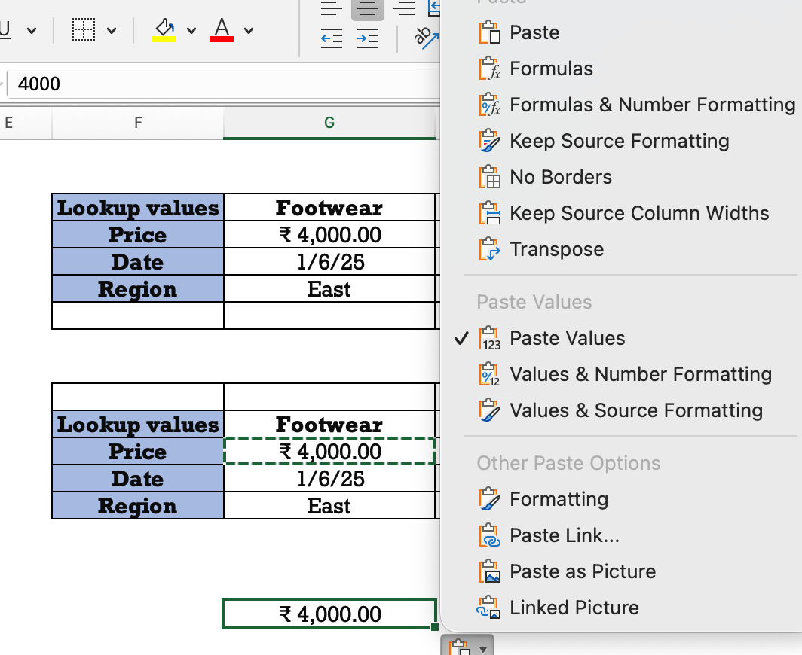

Question 2: Describe the functions and usefulness of 'Freeze Panes' and 'Split Panes' in Excel.

Freeze Panes
- Function: Locks rows and/or columns at the top or left of the worksheet so they remain visible as you scroll.
- Usefulness: Essential for large datasets where you need to always see headers (row 1) or identifiers (column A) to understand the data in other rows/columns.
- How it works: Select the cell below the rows and to the right of the columns you want to freeze, then use View > Freeze Panes.
- Options: Freeze Top Row, Freeze First Column, Freeze Panes (for rows and columns).
Split Panes
- Function: Divides the worksheet window into multiple, independently scrollable panes (sections).
- Usefulness: Great for viewing different, non-contiguous parts of the same sheet at once, like comparing data in Column D with data in Column Z, or Row 5 with Row 500.
- How it works: Select the cell below the rows and to the right of the columns where you want the split, then click View > Split (or use the dedicated Split button).
- Key Difference: With Split, you get separate scroll bars for each pane, allowing all data to scroll; with Freeze, the frozen area is static and unscrollable.

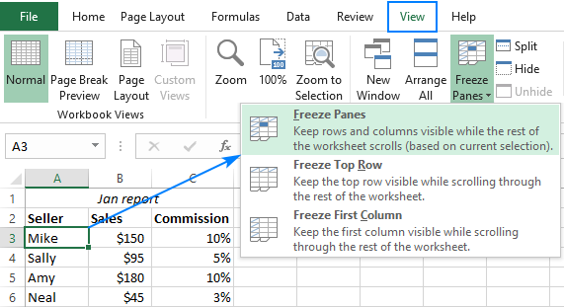

Question 3: Explain the difference between inserting a new row and inserting a new column in Excel. Can you insert multiple rows or columns at once?

Key Differences Between Inserting Rows And Column
- Rows: Horizontal arrangement (left-to-right), added by selecting cells/rows and inserting above/below, shifting data down.
- Columns: Vertical arrangement (top-to-bottom), added by selecting cells/columns and inserting left/right, shifting data to the right.

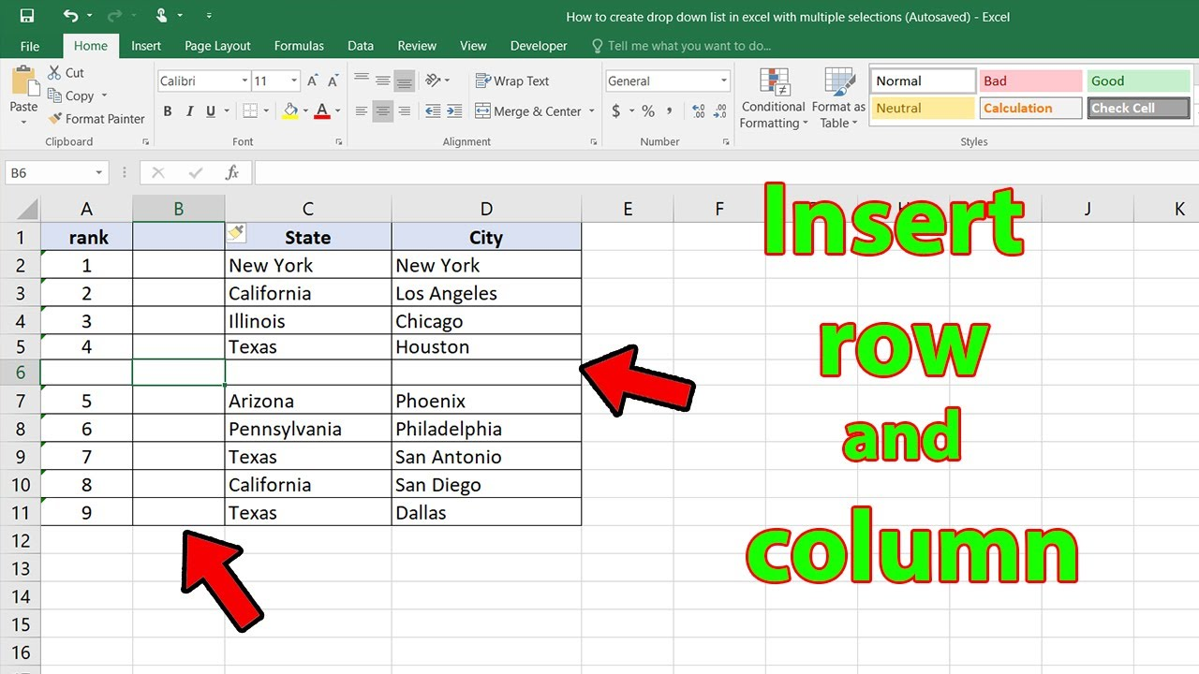

yes, we can insert multiple rows and columns at once by selecting the required numbers of rows or columns desired. Then using right click or short cut command Alt+Shift ++ we can perform the following action . Screen shot is attached below

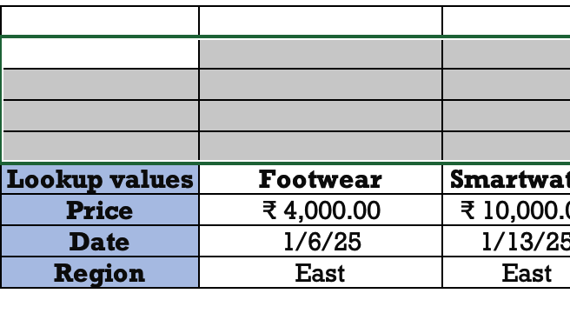

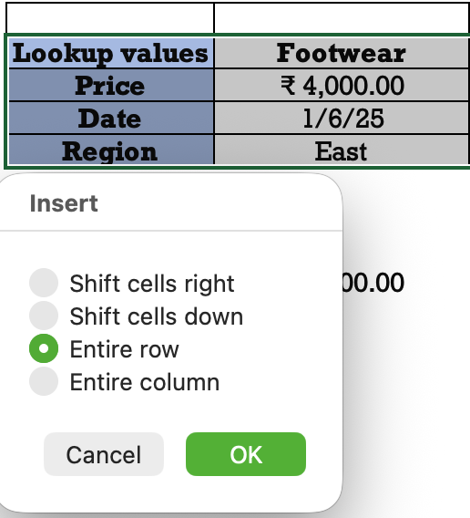

Question 4: What are logical functions in Excel? Provide examples of at least two logical functions and their applications.

Answer:

Logical functions help to in decision-making by testing specific conditions and returning different values based on whether the conditions are met (TRUE or FALSE). These functions are essential for data analysis and building dynamic spreadsheet.

Common logical functions include IF, AND, OR, NOT, IFS, and XOR.
Two fundamental logical functions and their practical applications:

The IF Function
The IF function are logical function used for comparison between a value and e desired result. It returns one value if the condition is TRUE and another value if the condition is FALSE.
- Syntax: =IF (logical_test, value_if_true, [value_if_false])
Application Example: Determining student results (Pass/Fail).
  - In a spreadsheet with student marks in cell B2, you can use the formula =IF(B2>=35, "Pass", "Fail").
  - If the value in B2 is greater than or equal to 35, the cell with the formula will display "Pass"; otherwise, it will display "Fail". This automates the grading process for a large number of students.

The AND Function (often combined with IF)
The AND function evaluates multiple logical conditions and returns TRUE only if all of the conditions are met. If any single condition is FALSE, the function returns FALSE. It is powerful when used within an IF statement to apply multiple criteria for a single decision.
Syntax: =AND (logical1, [logical2], ...)
Application Example: Determining eligibility for an employee bonus.
  - An employee needs a performance score of 80 or higher and an attendance rate of 90% or higher to qualify for a bonus.
  - Assuming performance is in cell A2 and attendance in B2, the combined formula would be: =IF(AND(A2>=80, B2>=0.9), "Bonus Awarded", "No Bonus").
  - This formula checks both conditions simultaneously. If both are TRUE, it returns "Bonus Awarded"; otherwise, it returns "No Bonus".
  - If FUNCATION :

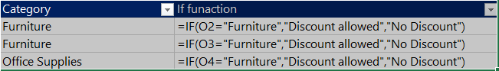

Category | If funaction
Furniture | Discount allowed
Furniture | Discount allowed
Office Supplies | No Discount
“AND” FUNCATION:
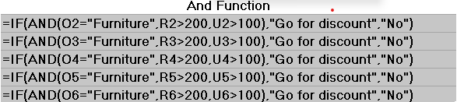
And Function
No
Go for discount
No
No

Question 5: Discuss the purpose of 'XLOOKUP' and how it differs from the traditional 'VLOOKUP' function.

Summary of Differences: XLOOKUP vs VLOOKUP
Feature | VLOOKUP | XLOOKUP
Lookup Direction | Right only (leftmost column lookup) | Both Left and Right (bi-directional)
Default Match | Approximate match (requires FALSE for exact) | Exact match (default setting)
Error Handling | Returns #N/A error by default | Built-in [if_not_found] argument for custom text
Data Sorting (Approx. Match) | Requires lookup column to be sorted ascending | Does not require sorting for approximate match
Formula Stability | Breaks if columns are inserted/deleted | Dynamic; adapts to column changes
Search Order | Top to bottom only | Top/Bottom, Bottom/Top, Binary search options
Return Multiple Columns | No (requires multiple formulas) | Yes (returns dynamic array of values)
Compatibility | All Excel versions | Microsoft 365, Excel 2021 only

Question 6: Create a worksheet titled 'Employee Data' with columns: Name, Age, Department. Add 5 rows of data.

Format as follows:
● Bold and center-align the header row
● Apply a fill color
● Auto-fit column width.

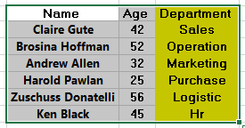

Question 7: Demonstrate how to insert and delete multiple rows and columns in Excel.

(Provide screenshots before and after the changes.)

Screen Shot Before the Change:

Screen Shot After the Change:

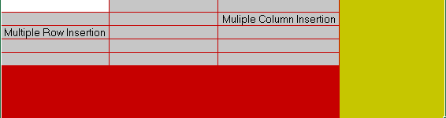

8. Question 8: Use Excel's 'Find and Replace' feature to update department names in a sample
table.
(Include a screenshot showing the replaced data).

1. Use of Find Feature:

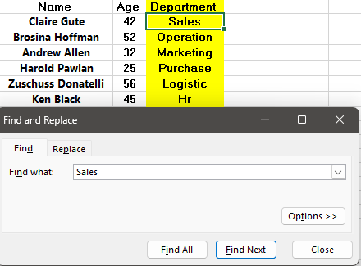

- Use of Replace Features:

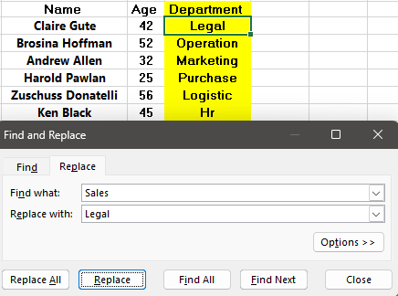

9: Create a small numerical dataset and apply the following functions:
● AVERAGE
● MAX
● MIN

(Include a screenshot showing the formulas and their results.)

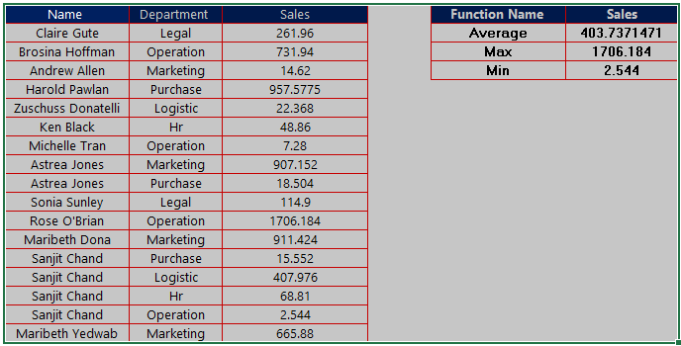

10: You're working with a dataset that contains missing values. As a Data Scientist, explain how you'd detect and handle missing data using Excel. Mention tools like:
● Go To Special
● ISBLANK
● COUNTBLANK

(Include a screenshot showing how blanks are identified or processed.)

Part 1: Detecting Missing Data in Excel
Detecting missing values (often represented as blank cells in Excel) is the first critical step. We use quantitative and visual methods for this purpose.
1. Quantitative Summary using COUNTBLANK
The COUNTBLANK function provides a quick, high-level summary of the extent of missing data in a range. This helps assess data quality at a glance and decide if a column has too many missing values to be useful.
- Application: To count the number of empty cells in a specific column (e.g., Column C), you would use the formula:
=COUNTBLANK(C:C)
- Data Scientist's Use Case: Running this function across all columns helps quantify missingness and prioritize which variables need immediate cleaning.
2. Cell-Level Flagging using ISBLANK
The ISBLANK function is used in a "helper column" to evaluate whether an individual cell is empty. It returns TRUE if the cell is blank and FALSE otherwise.
- Application: If your data starts in Row 2, you might put this formula in a new column E:
=ISBLANK(A2)
- Data Scientist's Use Case: By filtering for TRUE in the helper column, you can isolate every single row that has a missing value in column A. This is powerful when combined with IF statements to handle missing values logically (e.g., =IF(ISBLANK(A2), "Missing Data Point", A2)).

3. Visual Identification & Selection using 'Go To Special'
The Go To Special tool is an essential UI feature for visually identifying and selecting all blank cells across a large selection of data simultaneously, preparing them for a mass operation.
- Application Steps:
  - Select the entire data range you want to scan.
  - Press F5 or Ctrl + G to open the Go To dialog box, then click the Special... button.
  - Select the Blanks radio button and click OK.
- Use Case: This instantly highlights every blank cell. You can now visually inspect where the data gaps are clustered, or immediately apply a fill/color to make them stand out in the dataset.

Part 2: Handling Missing Data in Excel
Once detected, missing data must be addressed. Common strategies involve deletion (if data loss is minimal) or imputation (filling in missing values).
1. Deletion of Records (Listwise Deletion)
If a small percentage of rows have many critical missing values, it may be statistically sound to remove those entire rows.
- Excel Method: After using Go to Special > Blanks (as described above), you can select any visible blank cell, right-click, select Delete and choose Entire row.

- 2. Imputation using 'Go To Special'
Imputation means replacing the missing value with a substitute value (e.g., the mean, median, mode, or a placeholder like "Unknown"). The Go To Special tool streamlines this process.
- Imputing a Constant Value ():
  - Select the relevant data range.
  - Use Go To Special > Blanks to select all empty cells.
  - Type the replacement value (e.g., Unknown) and press Ctrl + Enter. This fills all selected blank cells instantly.
- Imputing with a Formula (e.g., using the Average/Mean): This requires a bit more care but is possible in Excel. You'd typically calculate the average of the non-blank values elsewhere (e.g., =AVERAGE(A:A)), and then use the Go To Special method to fill the blanks with that calculated average value.
3. Imputation using ISBLANK within an IF statement
For dynamic imputation where you want the substitute value to depend on other data points in the same row, you use ISBLANK in a helper column to generate a cleaned version of your original column.
- Excel Formula Example: If you want to replace any blank income value with the department's median income (which you've pre-calculated and placed in cell Z100), you could use:
=IF(ISBLANK(C2), $Z$100, C2)
By combining these functions and tools, a data professional can effectively manage missing data directly within the Excel environment before moving to more advanced analysis platforms.

